**LAPORAN**

**TUGAS BESAR TEORI BAHASA AUTOMATA**



**Disusun oleh :**

Fakhri Fadillah Rahman - 1301210386

Rafly Muhammad Ghifari - 1301210442

Gibran Shevaldo - 1301213398

**Program Studi S1 Informatika**

**Fakultas Informatika**

**Universitas Telkom**

**2022/2023**

CFG

| *Catatan: \n merepresentasikan "enter"*  <start> ::= if <kondisi> { \n <aksi> \n } <else>  <kondisi> ::= <variabel> > <variabel>  <kondisi> ::= <variabel> < <variabel>  <kondisi> ::= <variabel> == <variabel>  <kondisi> ::= <variabel>  <aksi> ::= <variabel> = <variabel> + <variabel> <aksi_lain>  <aksi> ::= <variabel> = <variabel> * <variabel> <aksi_lain>  <aksi> ::= <variabel> = <variabel> - <variabel> <aksi_lain>  <aksi> ::= <variabel> = <variabel> / <variabel> <aksi_lain>  <aksi_lain> ::= \n <aksi>  <aksi_lain> ::= ε  <else> ::= else <start>  <else> ::= else { \n <aksi> \n }  <else> ::= ε |
| --- |

Di bawah ini kami lampirkan ilustrasi penerapan CFG di atas dalam bentuk PDA :

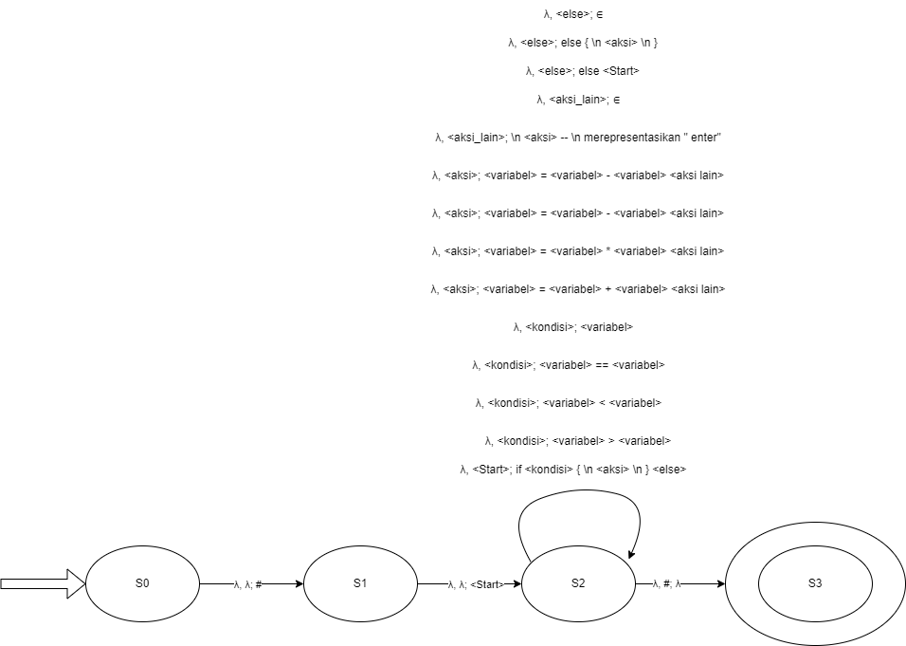

**Parse Table**

|  | **a** | **b** | **c** | **d** | **>** | **<** | **==** | **=** | **\*** | **-** | **+** | **/** | **{** | **}** | **(** | **)** | **if** | **else** | **EOS** |
| --- | --- | --- | --- | --- | --- | --- | --- | --- | --- | --- | --- | --- | --- | --- | --- | --- | --- | --- | --- |
| **STATEMENT** | error | error | error | error | error | error | error | error | error | error | error | error | error | error | error | error | if <kondisi> { <aksi> } else { <aksi> } | error | error |
| **KONDISI** | <variabel> <operator> <variabel> | <variabel> <operator> <variabel> | <variabel> <operator> <variabel> | <variabel> <operator> <variabel> | error | error | error | error | error | error | error | error | error | error | error | error | error | error | error |
| **AKSI** | <variabel> = <variabel> <operator> <variabel> | <variabel> = <variabel> <operator> <variabel> | <variabel> = <variabel> <operator> <variabel> | <variabel> = <variabel> <operator> <variabel> | error | error | error | error | error | error | error | error | error | error | error | error | error | error | error |
| **OPERATOR** | error | error | error | error | > | < | == | error | * | - | + | / | error | error | error | error | error | error | error |
| **VARIABEL** | a | b | c | d | error | error | error | error | error | error | error | error | error | error | error | error | error | error | error |